POLITECNICO
DASTU
MILAN 26-28 JUNE 2017
Hotel Residence Zumbini 6
Via Zumbini, 6
Please fill the following reservation form and send it through e-mail to info@hotelresidencezumbini6.com in order to confirm your reservation within MAY, 10, 2017.
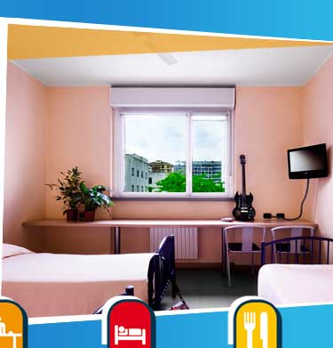
Hotel Residence Zumbini 6
Via V. Zumbini, 6 - 20143 Milano - Italy
Tel. (+39) 02 36556604
www.hotelresidencezumbini6.com
email. info@hotelresidencezumbini6.com

ROOMS RESERVATION

Please, write in the subject: Transforming Care Conference

Please confirm the following reservation:
Arrival date: _______________________________ (Check-in starting from …..)
Departure date: _______________________________ (Check-out until …….)

I would like to book:
a single room with private bathroom €57,00/night (basic breakfast included)

Double room with bathroom single use €67,00/night (basic breakfast included)

Please note that there is a limited number of rooms booked for each category, therefore those who book in advance will be privileged.

Name and address:__________________________________________________________________________
Address: ____________________________________________________________________________________
City/Town:__________________________________________________________________________________
Phone number:____________________________ Fax number: __________________________________
Credit card: _____________________________________________ Expiry date: _____________________
Signature: ___________________________________________________________________________________
Note well: the above-mentioned reservation is guaranteed. Cancellations over the deadline or no shows will involve one night charge. In case you need to amend or cancel the reservation, we kindly ask you to do it within 24h hours before your arrival.
____________________________________________________________________________________________
(date, stamp, signature)

